**BRIEF HISTORY OF COMPUTING**

Computing, as we know it today, has a long and rich history that spans centuries, evolving from early tools used for basic calculations to the powerful machines we now carry in our pockets. Below is an expanded overview of the major milestones in the history of computing:

**1. Early Tools: The Foundation of Computing**

The concept of computation predates modern machines and can be traced back thousands of years. Ancient civilizations devised early tools to perform basic arithmetic and manage large quantities of data.

* **The Abacus (c. 2500 BCE)**: One of the earliest known tools for calculation, the abacus, was developed in Mesopotamia and later used across the ancient world, including by the Greeks, Romans, and Chinese. The abacus allowed users to perform basic arithmetic operations, such as addition and subtraction, using beads that moved along rods.
* **The Antikythera Mechanism (c. 100 BCE)**: Discovered in an ancient Greek shipwreck, this is considered one of the first known analog computers. It was used to predict astronomical positions and eclipses, highlighting the ancient use of mechanical systems for complex calculations.

**2. The Mechanical Era: 17th to 19th Century**

The mechanical era saw the development of devices that laid the groundwork for modern computers. Innovators began to design and build machines capable of automating arithmetic calculations, leading to the first conceptualizations of computers.

* **Pascal’s Calculator (1642)**: Invented by French mathematician and philosopher **Blaise Pascal**, this machine could add and subtract, making it one of the earliest mechanical calculators. It used a system of gears and dials to perform operations.
* **Leibniz’s Step Reckoner (1673)**: German mathematician **Gottfried Wilhelm Leibniz** improved upon Pascal’s invention with the Step Reckoner, which could multiply and divide as well. Leibniz’s device introduced binary arithmetic, a foundational concept for digital computing.

**3. The Analytical Engine: The First Conceptual Computer**

**Charles Babbage**, an English mathematician, is often regarded as the "father of the computer" due to his design of the **Analytical Engine** in the 1830s.

* **The Analytical Engine (1837)**: This was the first design for a general-purpose mechanical computer. Unlike earlier machines, the Analytical Engine was not limited to a single calculation but could be programmed to perform a variety of operations. It had features that closely resemble modern computers, such as:
  + **Input/Output**: Data was entered using punched cards, and results were printed out.
  + **Control Unit**: A basic system to manage operations.
  + **Memory**: It had the capacity to store numbers. Unfortunately, Babbage never completed a working model of the Analytical Engine due to technical limitations of the era, but his vision inspired future generations of computer scientists.
* **Ada Lovelace**: **Ada Lovelace**, a mathematician and writer, worked with Babbage and is credited with writing the first algorithm intended to be processed by a machine, making her the world’s first computer programmer. Her notes on the Analytical Engine suggested it could do more than just calculations, envisioning the potential for computers to create art or music.

**4. The Electromechanical Era: Early 20th Century**

During the early 1900s, inventors began integrating electrical components into mechanical machines, leading to more powerful and efficient computing devices.

* **Zuse’s Z3 (1941)**: German engineer **Konrad Zuse** created the Z3, the first fully functional electromechanical computer. The Z3 used relays (electromechanical switches) and was capable of performing binary arithmetic and basic logical operations, key components of modern computers.
* **Harvard Mark I (1944)**: This large-scale electromechanical computer, designed by **Howard Aiken** and built by IBM, could perform lengthy calculations automatically. It was used by the U.S. Navy during World War II and marked a significant leap in computational technology.

**5. The Electronic Era: The Dawn of Modern Computing**

The introduction of fully electronic components in the mid-20th century heralded the birth of the modern computer. These machines no longer relied on mechanical parts and could perform calculations much faster.

* **ENIAC (1945)**: The **Electronic Numerical Integrator and Computer (ENIAC)** was the first general-purpose electronic digital computer. Developed by **John Mauchly** and **J. Presper Eckert**, it used vacuum tubes to perform calculations. ENIAC was initially designed for calculating artillery firing tables for the U.S. Army but quickly became a tool for a wide variety of applications.
* **Transistors (1947)**: The invention of the transistor at Bell Labs by **John Bardeen**, **Walter Brattain**, and **William Shockley** revolutionized computing. Transistors replaced bulky and unreliable vacuum tubes, enabling computers to become smaller, faster, and more energy-efficient. This marked the beginning of the second generation of computers.

**6. The Age of Transistors and Integrated Circuits (1950s–1960s)**

With the invention of transistors, computers began to shrink in size and grow in capability. The invention of integrated circuits (ICs) in the 1960s further miniaturized computer components, paving the way for personal computers.

* **Integrated Circuits (ICs)**: **Jack Kilby** of Texas Instruments and **Robert Noyce** of Fairchild Semiconductor independently developed integrated circuits, which allowed multiple transistors to be embedded on a single chip. This advancement dramatically increased the power and efficiency of computers while reducing costs.
* **Mainframes and Minicomputers**: During this time, large-scale computers, known as mainframes, were used by businesses and government agencies. The 1960s also saw the rise of smaller, less expensive **minicomputers**, which made computing more accessible to universities and smaller organizations.

**7. The Personal Computer Revolution (1970s–1980s)**

The 1970s and 80s saw the advent of personal computing, bringing computers out of research labs and into homes, schools, and small businesses.

* **Apple I and II (1976, 1977)**: **Steve Jobs** and **Steve Wozniak** founded Apple and developed the Apple I and later the Apple II, which became one of the first commercially successful personal computers. These computers featured a simple design, and the Apple II was widely used in homes and schools.
* **IBM Personal Computer (1981)**: IBM introduced its own personal computer, the IBM PC, in 1981. This machine set standards for personal computers, including the use of Microsoft’s MS-DOS operating system. Its open architecture allowed other companies to create compatible hardware and software, fostering a rapidly growing ecosystem around personal computing.
* **Graphical User Interface (GUI)**: In 1984, Apple introduced the **Macintosh**, the first commercially successful computer with a **graphical user interface (GUI)**. Instead of typing commands, users could interact with the computer using windows, icons, and a mouse, making computers more user-friendly and accessible.

**8. The Modern Era: Computing Today**

Today’s computing landscape is characterized by exponential growth in power and diversity of applications, ranging from mobile devices to cloud computing.

* **Smartphones**: With the release of the **iPhone** in 2007, computing truly went mobile. Smartphones now have more computing power than the early mainframe computers and are used for everything from communication to entertainment and productivity.
* **Cloud Computing**: The rise of cloud computing has allowed users and businesses to store and process data remotely. Services like Amazon Web Services (AWS), Microsoft Azure, and Google Cloud have transformed the way we access and utilize computing resources, allowing for scalability, flexibility, and remote collaboration.
* **Artificial Intelligence (AI)**: Advances in AI and machine learning have led to breakthroughs in fields like natural language processing, robotics, and autonomous vehicles. AI systems can now perform tasks such as speech recognition, image classification, and decision-making.
* **Quantum Computing**: While still in its early stages, quantum computing promises to revolutionize computing by solving problems that are currently intractable for classical computers. Companies like IBM, Google, and Microsoft are investing heavily in quantum research.

**BASIC COMPONENTS OF THE COMPUTER**

**Three Major Components of a Computer**

■ HARDWARE is the tangible or physical part of a computer system.

■ SOFTWARE is the non-tangible part that tells the computer how to do its job.

■ LIVEWARE refer to people who use and operate the computer system, write computer programs, and analyze and design the information system.

**1. Hardware Components**

Hardware refers to the physical components of a computer that can be seen and touched. These components work together to process data and perform tasks.

**a. Central Processing Unit (CPU)**

* **Function**: The CPU is often referred to as the "brain" of the computer. It is responsible for interpreting and executing most of the commands from the computer’s hardware and software.
* **Components**:
  + **Control Unit (CU)**: Directs the operation of the processor. It tells the computer’s memory, ALU (Arithmetic Logic Unit), and input/output devices how to respond to a program's instructions.
  + **Arithmetic Logic Unit (ALU)**: Performs all arithmetic and logic operations, such as addition, subtraction, and comparisons.
  + **Registers**: Small, high-speed storage locations that temporarily hold data and instructions during processing.

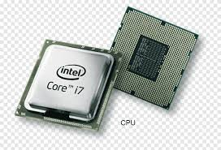

**b. Memory (RAM - Random Access Memory)**

* **Function**: RAM is the temporary storage that the CPU uses to store data that is actively being used or processed. It is volatile, meaning that all data is lost when the computer is turned off.
* **Importance**: The amount of RAM influences the computer's ability to run multiple applications simultaneously. More RAM generally results in faster performance, especially in multitasking environments.

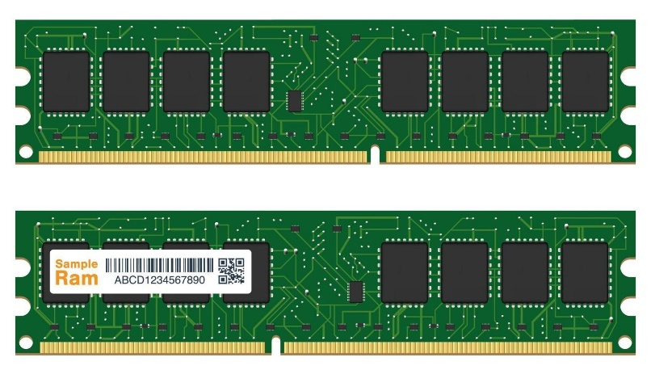

**c. Storage (Hard Disk Drive/SSD)**

* **Hard Disk Drive (HDD)**: A traditional storage device that uses magnetic disks to store data. It has a larger capacity compared to SSDs but is slower because it relies on spinning disks.
* **Solid-State Drive (SSD)**: An advanced storage device that uses flash memory to store data. It has no moving parts and is much faster than an HDD in terms of data access and boot-up times.
* **Function**: Both HDDs and SSDs are used for long-term storage of operating systems, applications, and personal files. Data stored here is non-volatile, meaning it is retained even after the computer is powered down.

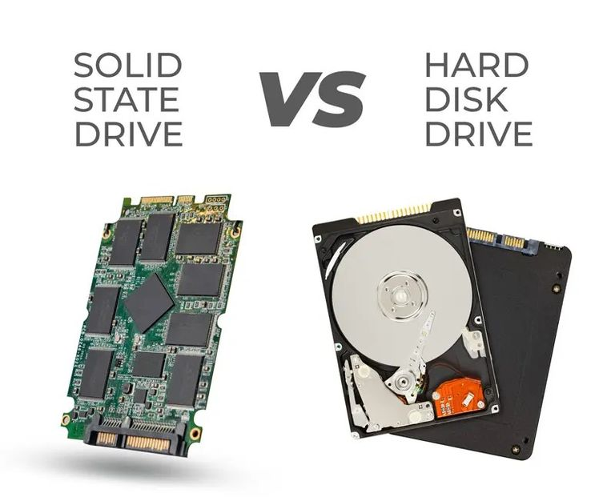

**d. Motherboard**

* **Function**: The motherboard is the primary circuit board that houses the CPU, memory, and other components. It facilitates communication between all the different hardware components of the computer.
* **Features**:
  + **Bus**: A communication system that transfers data between components.
  + **Chipsets**: Manage data flow between the CPU, memory, and other peripherals.
  + **Expansion Slots**: Allow the installation of additional components, like graphics cards or network cards.

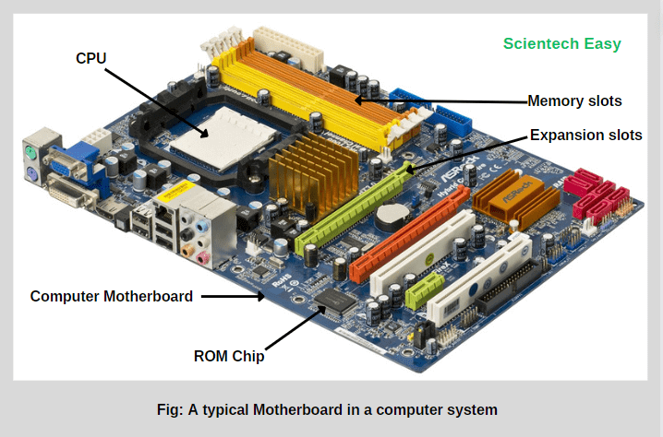

**e. Power Supply Unit (PSU)**

* **Function**: The PSU converts electricity from an AC outlet into the low-voltage DC power needed by the internal components of the computer.
* **Importance**: A reliable PSU is essential for the stability of the computer. An underpowered or faulty PSU can cause system instability or damage components.

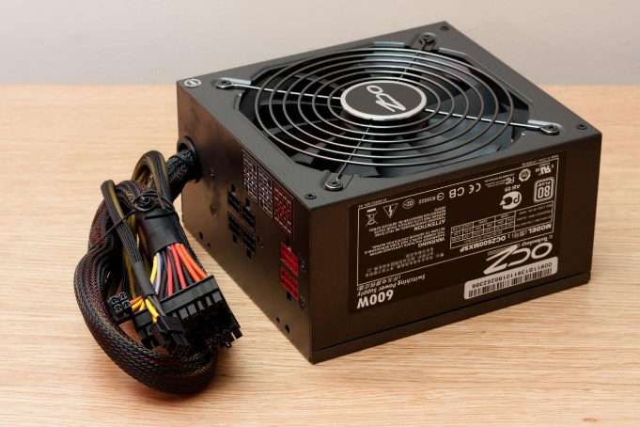

**f. Input Devices**

Input devices allow users to interact with and provide data to the computer.

* **Keyboard**: A primary input device used to enter text and commands.
* **Mouse**: A pointing device that allows users to select items and interact with the graphical user interface (GUI).
* **Other Examples**: Scanners, webcams, microphones, joysticks, etc.

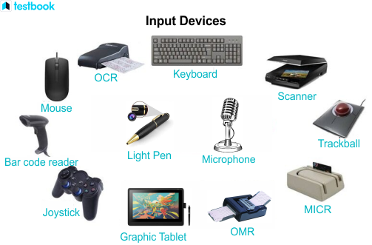

**g. Output Devices**

Output devices allow the computer to communicate information to the user.

* **Monitor**: The most common output device, used to display visuals and information.
* **Printer**: Outputs data in a physical form, such as text or images on paper.
* **Speakers**: Output audio data.

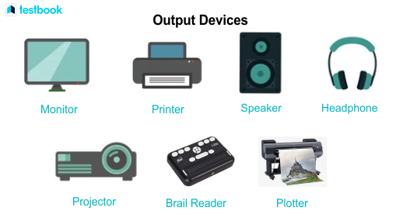

**h. Graphics Processing Unit (GPU)**

* **Function**: A specialized processor designed to handle complex graphics and visual rendering. GPUs are particularly important for gaming, video editing, and tasks involving visual computing.
* **Types**:
  + **Integrated Graphics**: Built into the CPU, suitable for basic tasks.
  + **Dedicated GPU**: A separate card, offering better performance for graphics-intensive tasks.

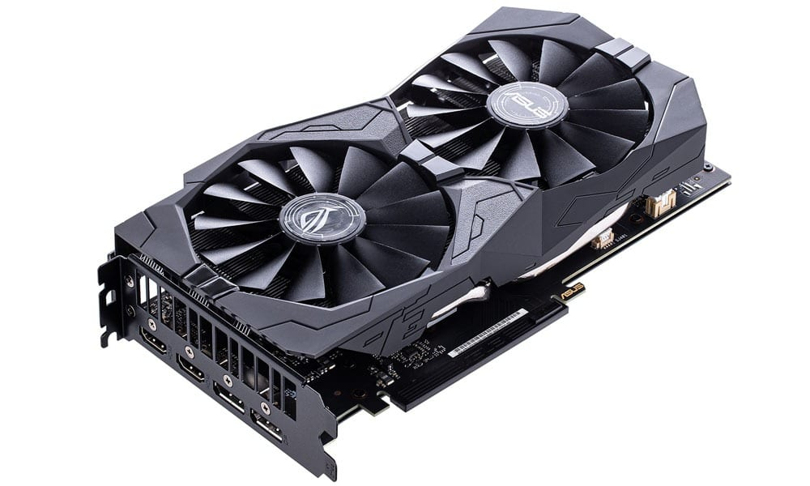

**i. Cooling System**

* **Function**: Cooling systems (such as fans and liquid cooling systems) are used to prevent overheating of the CPU, GPU, and other hardware components.
* **Types**:
  + **Air Cooling**: Uses fans to blow cool air over components.
  + **Liquid Cooling**: Uses liquid to absorb heat from components and dissipate it through radiators.

**2. Software Components**

Software refers to the set of instructions and programs that tell the hardware what to do. Without software, the hardware would not be able to perform any useful tasks.

**System Software**

**System software** is a type of software designed to manage and control the hardware components of a computer and provide a platform for running application software. It serves as the intermediary between the user, the applications they run, and the hardware.

**Examples of System Software:**

1. **Operating System (OS)**: The most important type of system software, it manages all other programs and hardware components. Examples include:
   * **Windows**
   * **macOS**
   * **Linux**
2. **Device Drivers**: Software that allows the operating system to communicate with hardware devices (e.g., printers, keyboards, monitors).
3. **BIOS/UEFI**: Firmware that initializes hardware during boot-up and loads the operating system.

**Utility Software**

**Utility software** is a subset of system software that is designed to help analyze, configure, optimize, or maintain a computer. It is essential for the smooth functioning of the system, focusing on performance and security.

**Examples of Utility Software:**

1. **Antivirus Software**: Protects the computer from malware and viruses (e.g., Norton, McAfee).
2. **Disk Cleanup Tools**: Remove unnecessary files to free up disk space (e.g., Windows Disk Cleanup).
3. **Backup Software**: Automatically backs up files and data (e.g., Acronis, Backup Exec).
4. **Compression Tools**: Compress or decompress files to save storage (e.g., WinRAR, 7-Zip).
5. **Defragmentation Tools**: Optimize the performance of hard drives by organizing scattered data (e.g., Windows Disk Defragmenter).
6. **File Management Tools**: Provide advanced ways to organize files and directories (e.g., Total Commander).

**Application Software**

* **Function**: Application software includes programs that perform specific tasks for users, such as word processing, browsing the internet, or playing games.
* **Examples**:
  + **Microsoft Word**: A word processing application.
  + **Google Chrome**: A web browser for internet access.
  + **Photoshop**: An application for image editing and graphic design.
  + **Importance**: These programs help users complete their work, communicate, and entertain themselves.

**LIVEWARE**

Liveware is a term used to refer to the human operators, users, or personnel involved in the operation, management, or interaction with computer systems and technology. In the context of computer systems, liveware complements the other components of the system, including hardware, software, and data. Liveware is crucial for the effective operation and utilization of computer systems. It includes individuals with various roles and responsibilities, such as:

* **End Users**: People who interact with computer systems to perform tasks or access information. They may use applications, browse the web, create documents, or communicate electronically.
* **Operators:** Individuals responsible for managing and maintaining computer systems, including monitoring performance, configuring hardware and software settings, and troubleshooting issues.
* **Administrators:** System administrators or IT professionals who oversee the overall operation and security of computer networks, servers, and infrastructure. They manage user accounts, enforce security policies, and ensure system reliability.
* **Programmers and Developers:** Individuals who write, test, and debug software code to create applications, websites, and other digital solutions. They use programming languages and development tools to design and implement software functionality.
* **Support Personnel:** Technical support staff who assist users with troubleshooting problems, resolving technical issues, and providing guidance on using computer systems effectively.

**NETWORKING COMPONENTS**

In modern computers, networking components are also considered essential.

**a. Network Interface Card (NIC)**

* **Function**: A hardware component that allows the computer to connect to a network (either wired or wireless).
* **Types**: Ethernet NICs for wired connections and Wi-Fi NICs for wireless connections.

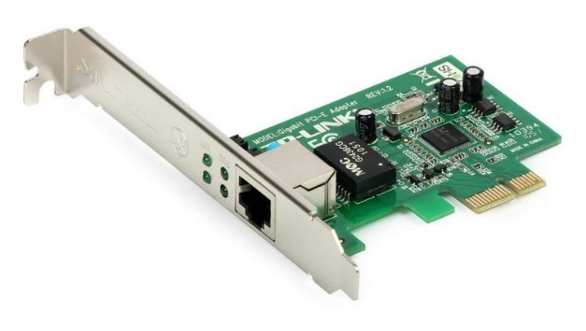

**b. Router/Modem**

* **Function**: These devices connect computers to the internet. A modem connects to the internet service provider (ISP), while a router directs traffic between the modem and various devices on the network.
* **Importance**: Networking allows computers to communicate with other devices and access internet services.

**c. Switches and Hubs**

* **Function**: Networking hardware used to connect multiple devices on a local network (LAN). Switches are more advanced than hubs and can manage data flow more efficiently.

**DIVERSE AND GROWING COMPUTER/DIGITAL APPLICATIONS.**

Computer and digital applications have diversified and grown significantly, touching almost every aspect of human life and industry. Here’s a look at various sectors where computers and digital technologies have transformed operations:

**1. Healthcare and Medicine**

Computers and digital applications have revolutionized healthcare by improving diagnosis, treatment, and patient care.

* **Electronic Health Records (EHRs)**: Digital records that allow for the efficient management of patient data, improving accuracy and accessibility.
* **Medical Imaging**: Technologies like MRI, CT scans, and X-rays depend on computers to process and analyze images for diagnosis.
* **Telemedicine**: Enables remote consultations, diagnosis, and treatment using video conferencing and mobile applications.
* **AI in Diagnostics**: AI models are used for early disease detection, such as in cancer screening, predicting heart conditions, and detecting chronic diseases (e.g., AI-driven radiology and pathology analysis).
* **Wearable Health Devices**: Fitness trackers and smartwatches monitor vital signs like heart rate, activity levels, and sleep patterns to help users track their health.

**2. Education**

Digital technology has transformed how education is delivered, making learning more accessible and interactive.

* **E-Learning Platforms**: Websites and apps like Coursera, Udemy, and Khan Academy provide courses and tutorials on a wide range of subjects.
* **Virtual Classrooms**: Tools like Zoom, Microsoft Teams, and Google Classroom enable online learning and collaboration.
* **Computer-Based Training (CBT)**: Software programs designed to deliver training on various subjects and skills in an interactive way.
* **Interactive Whiteboards and Smartboards**: These enhance classroom teaching by integrating multimedia and interactive lessons.

**3. Business and Commerce**

Digital technology is at the core of modern business operations, enabling faster, more efficient, and global operations.

* **E-commerce Platforms**: Websites like Amazon, Alibaba, and eBay allow consumers to buy goods and services online.
* **Customer Relationship Management (CRM)**: Software like Salesforce helps businesses manage customer interactions and data.
* **Cloud Computing**: Enables businesses to store data and run applications remotely, providing flexibility and scalability (e.g., Amazon Web Services, Microsoft Azure).
* **Enterprise Resource Planning (ERP)**: Systems like SAP and Oracle streamline business processes by integrating various functions like HR, finance, supply chain, and more.
* **Digital Marketing**: Techniques such as SEO, PPC, email marketing, and social media marketing use digital platforms for targeted advertising and customer engagement.

**4. Entertainment and Media**

The entertainment industry has undergone a complete transformation due to the advancement of digital technology.

* **Streaming Services**: Platforms like Netflix, YouTube, and Spotify provide digital media (movies, music, and shows) on-demand.
* **Video Games**: Modern gaming consoles and PCs use advanced hardware and AI to provide immersive, interactive entertainment.
* **Animation and CGI**: Computers are used in creating digital effects and animations for movies and video games.
* **Virtual Reality (VR) and Augmented Reality (AR)**: Used for immersive experiences in gaming, training simulations, and virtual events.
* **Social Media**: Platforms like Facebook, Instagram, and TikTok have reshaped communication and media sharing.

**5. Banking and Finance**

The financial industry relies heavily on computers for transaction processing, data analysis, and decision-making.

* **Online Banking**: Allows users to access banking services such as money transfers, bill payments, and account management from computers or mobile devices.
* **Cryptocurrency and Blockchain**: Digital currencies like Bitcoin and decentralized applications based on blockchain technology have emerged as new financial models.
* **Automated Trading**: Computers are used in algorithmic trading, which allows transactions to be executed faster and more efficiently.
* **Digital Wallets**: Applications like PayPal, Google Pay, and Apple Pay enable secure online payments and transactions without physical cards.
* **Artificial Intelligence in Finance**: AI-driven applications predict market trends, perform risk assessments, and detect fraud.

**6. Communication and Collaboration**

Communication has become faster and more accessible with the advent of digital tools and applications.

* **Email and Instant Messaging**: Platforms like Gmail, Outlook, WhatsApp, and Slack are widely used for both personal and professional communication.
* **Video Conferencing**: Zoom, Skype, and Microsoft Teams allow people to meet virtually, bridging geographical distances.
* **Social Networking**: Facebook, Twitter, and LinkedIn facilitate interaction, knowledge sharing, and professional networking.
* **Collaboration Tools**: Tools like Google Drive, Trello, and Asana are used for document sharing, project management, and teamwork.

**7. Science and Research**

Digital tools are essential in conducting experiments, data analysis, and modeling in scientific research.

* **Data Analytics**: Software like MATLAB, R, and Python libraries are used for scientific data analysis and visualization.
* **Simulation and Modeling**: In fields like physics, engineering, and biology, computers run simulations that predict behavior under different conditions.
* **Genomics and Bioinformatics**: Advanced computing helps in analyzing genetic data to understand diseases, drug discovery, and personalized medicine.
* **Robotics**: Robots are used in both experimental setups and practical applications in healthcare, manufacturing, and exploration.
* **Supercomputing**: High-performance computers are used for complex scientific calculations, such as climate modeling, drug research, and quantum mechanics simulations.

**8. Transportation and Logistics**

Computers play a major role in the development of modern transportation and logistics.

* **Autonomous Vehicles**: Self-driving cars, such as those developed by Tesla, rely on complex AI and computing systems for navigation and safety.
* **Logistics Management Systems**: Companies like FedEx and UPS use software to optimize routes, track shipments, and manage inventory.
* **GPS and Navigation Systems**: Applications like Google Maps and Waze provide real-time traffic updates and optimized routes.
* **Drones**: Used in both consumer deliveries (like Amazon's drone delivery) and military applications.
* **Air Traffic Control**: Computers manage the complex task of monitoring and controlling the movement of aircraft, ensuring safe and efficient operations.

**9. Manufacturing and Industry (Industry 4.0)**

The manufacturing sector has seen significant growth through automation and digital technology.

* **Computer-Aided Design (CAD)**: Software like AutoCAD is used to design products and structures before manufacturing.
* **Robotics and Automation**: Robots are used in manufacturing for precision tasks, reducing the need for human intervention in dangerous environments.
* **3D Printing**: Computer-controlled machines create physical objects from digital models, transforming prototyping and production.
* **Internet of Things (IoT)**: Devices equipped with sensors communicate in real-time to optimize industrial processes and predictive maintenance.
* **Smart Factories**: In Industry 4.0, the integration of IoT, AI, and automation systems has led to more efficient, flexible, and interconnected manufacturing environments.

**10. Government and Public Services**

Governments use computers to improve service delivery, transparency, and governance.

* **E-Government Services**: Citizens can access services like tax filing, voting registration, and public information online.
* **National Security**: Cybersecurity systems protect national infrastructure and government databases from cyber-attacks.
* **Public Safety**: Digital systems like CCTV cameras and facial recognition software enhance law enforcement and crime prevention efforts.
* **Big Data Analytics**: Governments use data analytics to understand population trends, economic conditions, and improve policy-making.
* **Smart Cities**: Integration of IoT, AI, and big data in urban areas to improve infrastructure, traffic management, and sustainability.

**11. Agriculture**

Computers and digital tools are transforming the agricultural industry into smart farming techniques.

* **Precision Agriculture**: Use of GPS, sensors, and drones to monitor crops, optimize planting, and manage resources like water and fertilizers.
* **Automated Machinery**: Tractors and harvesters equipped with AI and GPS can perform tasks autonomously.
* **Weather Prediction and Data Analytics**: Advanced data analytics helps farmers predict weather patterns and optimize crop yields.

**12. Cybersecurity**

As digital technology grows, the need for cybersecurity becomes essential across all sectors.

* **Firewalls and Antivirus Software**: Protects against external threats and viruses.
* **Encryption**: Protects sensitive data like personal details and banking information.
* **Intrusion Detection Systems (IDS)**: Monitors network traffic to detect suspicious activities.
* **Artificial Intelligence in Cybersecurity**: AI is being used to detect, prevent, and respond to cyber threats faster and more effectively.

**INFORMATION PROCESSING AND ITS ROLES IN SOCIETY.**

**Information processing** refers to the series of actions taken to collect, manipulate, store, and disseminate data in a meaningful way. The main components of information processing include **data input**, **data processing**, **data storage**, **data retrieval**, and **data output**. The field plays a critical role in modern society by influencing various sectors, from education to business, healthcare, and governance. Below is an exploration of information processing and its roles in different societal contexts.

**1. The Process of Information Processing**

The key stages involved in information processing are:

**a. Data Collection (Input)**

This is the initial stage, where raw data is gathered from various sources, such as sensors, surveys, or transactions. For instance, in retail, data is collected from customer transactions, online behaviors, or product inventory.

**b. Data Processing**

The collected data is then processed or transformed into meaningful information. Processing can involve calculations, sorting, classification, or applying algorithms to the raw data. For instance, in financial institutions, software processes transaction data to update account balances and generate reports.

**c. Data Storage**

Processed information is stored for future use or further processing. Storage can take place in physical or cloud-based databases. With modern technology, storage solutions include databases, data lakes, and distributed cloud systems.

**d. Data Retrieval**

Information is retrieved from storage when needed, either for decision-making or further processing. Retrieval can happen on-demand or automatically through algorithms, such as in e-commerce systems that recommend products based on past user behavior.

**e. Data Output**

Finally, the processed information is presented in a form that can be easily interpreted, such as reports, charts, or dashboards. This data may be used by individuals, organizations, or machines to make decisions or carry out tasks.

**2. Roles of Information Processing in Society**

Information processing is foundational in how societies function today. Below are key roles that it plays across various sectors:

**1. Business and Commerce**

* **Efficient Decision Making**: Information processing enables businesses to analyze large datasets, identifying trends and patterns that guide better decision-making. Business intelligence tools process sales data to help managers optimize operations, marketing strategies, and inventory management.
* **Automation of Transactions**: Information processing allows for the automation of business operations, including payroll management, inventory tracking, and customer relationship management (CRM). For instance, companies like Amazon use sophisticated algorithms to process user data and optimize product recommendations.
* **Supply Chain Management**: Information processing streamlines logistics and supply chain operations by monitoring inventory levels, predicting demand, and optimizing delivery routes. This results in cost savings, reduced wastage, and timely deliveries.

**2. Healthcare**

* **Electronic Health Records (EHRs)**: Information processing is key to managing patient records, tracking medical histories, and processing billing information in hospitals and clinics. It enhances the quality of care by providing healthcare providers with real-time access to patient data.
* **Diagnostics and Medical Imaging**: Advanced processing of medical images (e.g., CT scans, MRIs) allows for accurate diagnosis and early detection of diseases. Machine learning models process large datasets to identify patterns in medical conditions, leading to more precise and personalized treatments.
* **Telemedicine and Remote Monitoring**: Information systems enable healthcare providers to remotely monitor patients’ vital signs, symptoms, and treatment progress. Information processing helps provide healthcare services to remote and underserved areas through virtual consultations.

**3. Education**

* **Personalized Learning**: Information processing allows educators to develop personalized learning experiences based on students' performance data. Adaptive learning platforms use data analysis to modify the pace and style of content delivery, improving engagement and comprehension.
* **E-Learning Platforms**: Massive Open Online Courses (MOOCs) and other e-learning platforms rely on information processing systems to handle student registrations, track learning progress, and deliver assessments. Analytics tools process large volumes of user data to improve course content and structure.
* **Assessment and Feedback**: Information systems help teachers and institutions analyze student performance and provide timely feedback. Exam grading software, for instance, processes answers to generate performance metrics and reports.

**4. Government and Public Administration**

* **E-Governance**: Information processing systems allow governments to automate public services, making them more accessible and efficient. Services like tax filing, voter registration, and public record management rely heavily on information processing to function smoothly.
* **Data-Driven Policy Making**: Governments use processed information from population surveys, economic indicators, and other data sources to guide policy decisions. For instance, in urban planning, information processing helps track population growth, resource allocation, and infrastructure needs.
* **Public Safety and Security**: Information processing systems aid in crime prevention and law enforcement through tools such as facial recognition, biometrics, and surveillance data analysis. National defense and intelligence agencies also use advanced data processing for threat detection and strategic planning.

**5. Science and Research**

* **Data-Driven Discoveries**: Information processing is crucial in scientific research, especially in fields such as genomics, climate science, and space exploration. Big data processing helps researchers analyze complex datasets, model simulations, and generate insights from experimental results.
* **Simulation and Modeling**: Computers are used to process data for modeling scientific phenomena, such as weather patterns or drug behavior in clinical trials. Researchers can process and simulate thousands of variables to predict outcomes and inform decision-making.
* **Artificial Intelligence (AI) in Research**: AI and machine learning models rely on processing vast amounts of data to derive patterns, correlations, and predictions, aiding in research areas such as drug discovery, environmental sustainability, and robotics.

**6. Entertainment and Media**

* **Content Creation and Distribution**: Digital content platforms such as YouTube, Netflix, and Spotify process large amounts of data to recommend personalized content to users. Information processing enables video, music, and article distribution on demand.
* **Digital Animation and Special Effects**: Information processing technologies are used in video production, animation, and special effects to create stunning visual content for movies and games. Real-time rendering and 3D modeling software are based on complex data processing algorithms.
* **Interactive Media and Games**: Gaming applications process data to create interactive, immersive experiences. Multiplayer games rely on real-time processing of user inputs and networking data to deliver smooth gameplay.

**7. Banking and Finance**

* **Real-Time Transaction Processing**: Financial institutions use information processing systems to manage transactions, update accounts, and maintain records in real time. This enables banking services such as online payments, money transfers, and balance inquiries to function efficiently.
* **Fraud Detection**: Information processing algorithms are used to detect fraud by analyzing transaction data for suspicious patterns. Banks and credit card companies use predictive models to flag potentially fraudulent activities.
* **Risk Assessment and Investment Management**: Information systems process market data to help investors assess risk and optimize their portfolios. In stock trading, algorithms process huge datasets to identify trends and make split-second decisions in automated trading systems.

**8. Transportation and Logistics**

* **Route Optimization**: Information processing plays a crucial role in route optimization for logistics companies. GPS and traffic data are processed to determine the most efficient routes, reducing delivery times and fuel consumption.
* **Autonomous Vehicles**: Self-driving cars depend on real-time processing of sensor data to navigate roads safely. Complex algorithms analyze visual, radar, and lidar data to make decisions in real time.
* **Air Traffic Control**: Air traffic control systems rely on real-time data processing to monitor and direct aircraft movements, ensuring safe and efficient operations in the aviation industry.